**Lab 6: Regular Expressions**

1. Write a Program to find all the emails from a given text using Regular Expressions.
2. Write a Program to check whether the user has entered a valid email or not.
3. WAP to find all the lines starting with “<script” tag in a Webpage stored in a Text File.

**Given Sample Data**

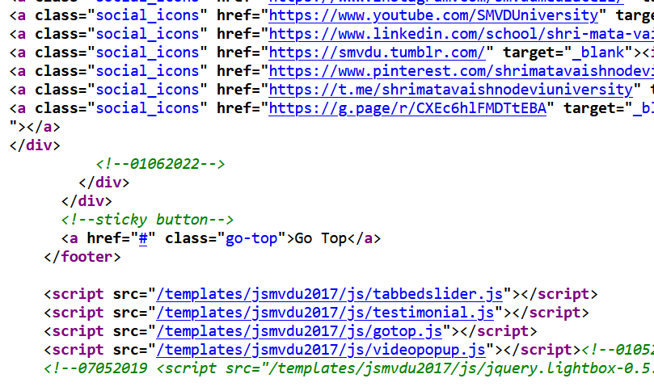

1. WAP to check the Strength of a Password input by the user.

The password will be considered Strong if it satisfies the following properties:

* *Password length must be 8 or more*
* *Password must contain special character*

1. WAP to extract all the IP addresses from a given text
2. WAP to extract all the mobile numbers from a given Text using Regular Expressions.